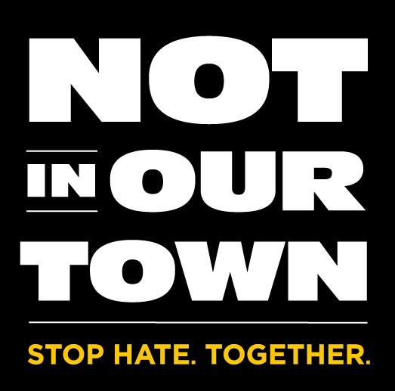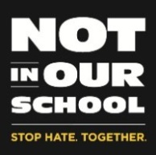

Not In Our Town: Class Actions Viewer Evaluation

Dear Viewer,

We are trying to make our work better and help funders understand the impact of what we do. We particularly would like to hear from you to help us learn how we can best follow through in addressing the issues raised in documentaries such as Not In Our Town: Class Actions and support efforts of people like you to make their communities better places to live in. So we would be grateful if you would take a few minutes to answer a few questions. If any question is uncomfortable, please feel free to skip it. Thank you in advance.

Note: Your email and phone number will not be shared with anyone or any group, either for money or for other contact purposes. Our main interest is to understand what you think of our efforts and your suggestions about how we can do better.

Location of Screening (City, State):

1. How long have you lived in your community?

☐ less than one year; ☐ about a year; ☐1-2 years; ☐3-9 years; ☐10+ years; ☐always

2. Where were you born? City______________ State ____ Country

3. Your Gender: ☐M ☐F Ethnicity:

4. How old are you? __________

5. Occupation/job (If any): __________________________________
Or: ☐student ☐home-maker ☐not working ☐retired

6. Did the film change your thinking about what schools, civic groups, or individuals in a community should do to promote acceptance, diversity, and respect?

☐ Yes ☐No

Please provide an example(s) of how the film changed your thinking, or if it didn’t change your thinking, why was that?

7. Have you ever done anything or been involved in countering hatred, intolerance, or bullying previously?

☐ Yes ☐No

What did you do? (check all that apply)

☐ intervene personally ☐talk with others about the problem ☐ join with others to organize a response

If yes, please provide an example of the action(s) you took.

8. Do you think that bullying, intolerance, or hateful behavior by some students against others is a problem in your child’s school/university (or, if you don’t have children in school) at schools/universities in your area?

☐ Yes, a serious problem
☐ Not a huge problem, but a concern
☐ A problem, but one that’s addressed fairly well
☐ Has not surfaced as a problem

(check all that apply to above)

☐ a problem in your child’s school.
☐ a problem in a school/district where you work
☐ a problem in a school in your community
☐ a problem in a school/university you attend
9. Do you think you’ll do anything if you witness or hear about intergroup hatred, intolerance, or bullying in the future in your child’s school or other local schools? (e.g. contact teachers or school staff, go to a school board meeting, talk with others, intervene, join with others to organize a response)

☐ Yes ☐No

If yes, please give us an idea of the kind of action(s) you would most likely take?

10. Did watching the film suggest any new ways for you to get involved, or what should be done differently?

☐ Yes ☐No

If yes, how did watching the film suggest new ways to get involved, or what should be done differently?

11. Is there something further we could do to help people like you get more engaged in countering hatred and conflict, and promoting respect and the positive value of diversity? What?

☐ Yes ☐No

If yes, what could we do?

11. Can we contact you later this year to find out if the film caused any long-term effects? If so, please share with us your phone number ( ) - ;
and/or email address

THANK YOU!
Please mail, email or fax your evaluation form to:
Not In Our Town, P.O. Box 70232, Oakland, CA 94612
Phone: 510-268-9675 Fax: 510-268-3606
Email: info@niot.org

